Graduating into the Unknown

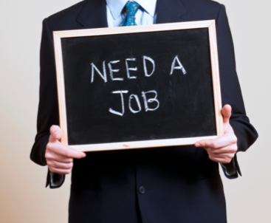
By: Amanda Cagnassola

Entering the workforce is one of the most exciting but challenging moments in a college graduate's life. The pandemic has made it difficult for experienced workers and recent college graduates find work. When the pandemic originally began, the job market was not hot, and no one knew what was in store for the future. The limited amount of job openings increased the competition. Graduates relied on networking and platforms like LinkedIn and Handshake, but there was still no clear path in how college students or anyone could navigate this pandemic. Graduates were going back to school, volunteering, taking online classes, or switching industries and preferences to secure a job.
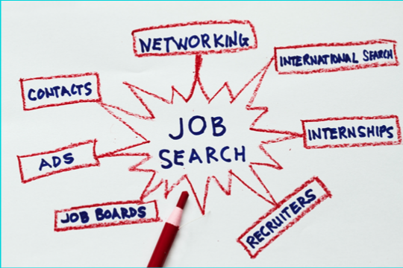
One of the most challenging problems recent graduates faced was getting the interview. Companies tended not to confirm they had received an application or decided not to move forward with a prospect. It left college students more in the dark as they navigated this new chapter in their lives. Once they could get the interview, the most challenging part was over, getting their foot in the door.

As I searched for a job, the market would be hot one week and cold the next. I was constantly scrolling through LinkedIn, forming connections with people in the industry I wanted to work in, and doing anything to keep myself busy. It was a roller coaster. Companies were interviewing me virtually, which allowed me to feel safe and comfortable with this pandemic, but it also caused problems. I was unable to grasp the culture of the company or the spaces they were once working in through just a zoom call. The job
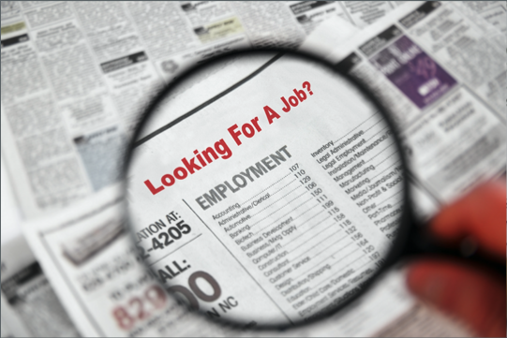
descriptions to me were just words. It didn’t allow me to really get a feel for the company and who I would be working with. I would ask tons of questions to grasp the knowledge I needed to know, but it still left me uncertain.

My friends and I began to accept offers and start the next chapter of our lives as adults in the real world. Companies could have incorporated a few things that could have made the process easier and more enjoyable.

- Using video would have helped the process. Video allows you to understand the culture, the people, and the possible spaces where you would be working. When you meet only the interviewer over zoom, it is not easy to decide if a job is a right fit for you. Video allows you to have the opportunity to meet your boss and other co- workers
- Another thing companies could have focused on was maximizing their communication with prospects. An automated message goes a long way compared to silence.
- Lastly, being transparent with candidates is extremely important because no one wants to waste time. Specifically, being upfront with the salary of a position, the company's status with COVID, and details about the job itself is necessary for a candidate when deciding on a job.

The one positive I had looking back on the length of my job search was the time to figure out what I really wanted. I was feeling rushed as March was approaching during senior year to find a job. But the pandemic allowed me to take my time because there was no rush while the world was on pause. I didn’t have people constantly asking me and applying pressure to my job search because everyone knew how difficult it was to find a job in this market.

